HTML ATTRIBUTES AND THEIR METHODS

# Attributes

## getAttribute

idName.getAttribute(“class”);

//it will give us the class of the element containing the id that you have specified

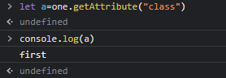

## hasAttribute

//has Attribute checks if your element has that value or not

//returns true or false

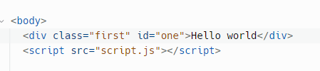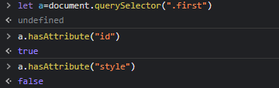

## setAttribute

//we an set the attribute of an element using js



## removeAttribute

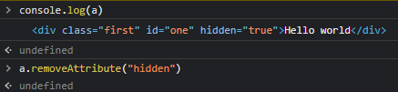

## .Attributes

//tocheck the attributes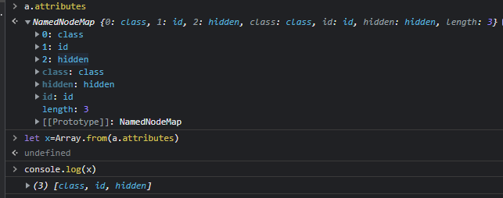

# Custom Attributes

## data-YourCustomAttributes

//and you can access your custom attributes using elem.**dataset.**YourCustomAttribute

Eg

